Project Proposal

# Group:

Manbir Guron

mnguron@iastate.edu

# Statement of Purpose:

In this project, my goal is to develop a system to analyze the vehicle and pedestrian traffic across a small area, and collect data about the particulate pollution. These two data streams will then be combined and compared to find which vehicles produce excess amounts of pollution, and to gain further insights about the trends behind localized particulate pollution and transport. One example of the object detection portion of my project side of is this [project](https://github.com/andrewssobral/vehicle_detection_haarcascades), which utilizes Open CV to track vehicles across a small area.

When complete, the unit would find the largest polluters that pass through a specific area, allowing specific vehicle owners and local people to understand their individual effect upon the local environment.

# Project Overview:

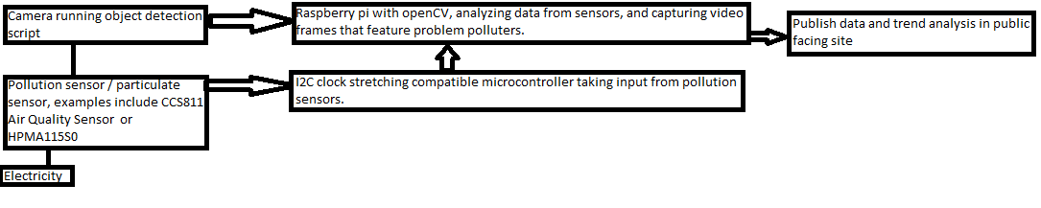Break down the project into a systems level diagram. Also add more specifics stemming from the overall goal.

The project will require two different sensors at the chosen location, with the first being the camera used for object detection, and the second being the pollution sensor. Depending on the exact pollution sensor used, the pollution sensor may need to be wired into an I2C clock stretching compatible microcontroller, which would necessitate a connection between the I2C clock stretching compatible microcontroller and the Raspberry PI that is running the full object detection script. This solution is due to the fact that OpenCV has to run in a computer with a full operating system, which a normal Arduino would not provide. This dual microcontroller strategy could be avoided if the I2C clock on the Raspberry pi was to be slowed, but research has shown that this approach may not work consistently.

The Raspberry pi will run an OpenCV script that will detect and count each vehicle object in the frame at each point. This data about vehicle counts will then be compared to the incoming pollution data, and if the pollution data is above the expected range for the car count at a particular time, the Raspberry pi will then save the next frame of video.

The general pollution data, data about moments of high pollution, and vehicle count data will then be sent by internet to an AWS IOT account connected to an AWS site, which will publish the gathered data.

An extension of this project would involve integrating a machine learning framework to get a more precise correlation between the amount of pollution generated locally and the types and counts of vehicles passing at a certain point in time. This would be done with further processing on a remote server using HOG (Histogram of gradient) feature extraction and a support vector machine classifier to classify vehicles in a video stream.

# Work Schedule:

March 7th – Deadline to obtain all free parts from ETG, continued research on software and order particulate sensor, begin software work

March 14th –Deadline to obtain particulate sensor and miscellaneous parts, initial OpenCV and webcam integration

March 28th –Last date to finish object detection script, connect and test all controllers and sensors

April 4th – End of troubleshooting data connections between sensors and microcontrollers, have full framework for all software

April 21st – Finish outdoor installation and have all software in working condition

April 28th – End date, finish continued outdoor and network testing program finished, Software fully functional, AWS site exists

# Group Organization:

I will publish all code to the repository hosted [here](https://github.com/MGuron/EE186Project), with further technical documents and schematics also stored within that repository.